Program 1
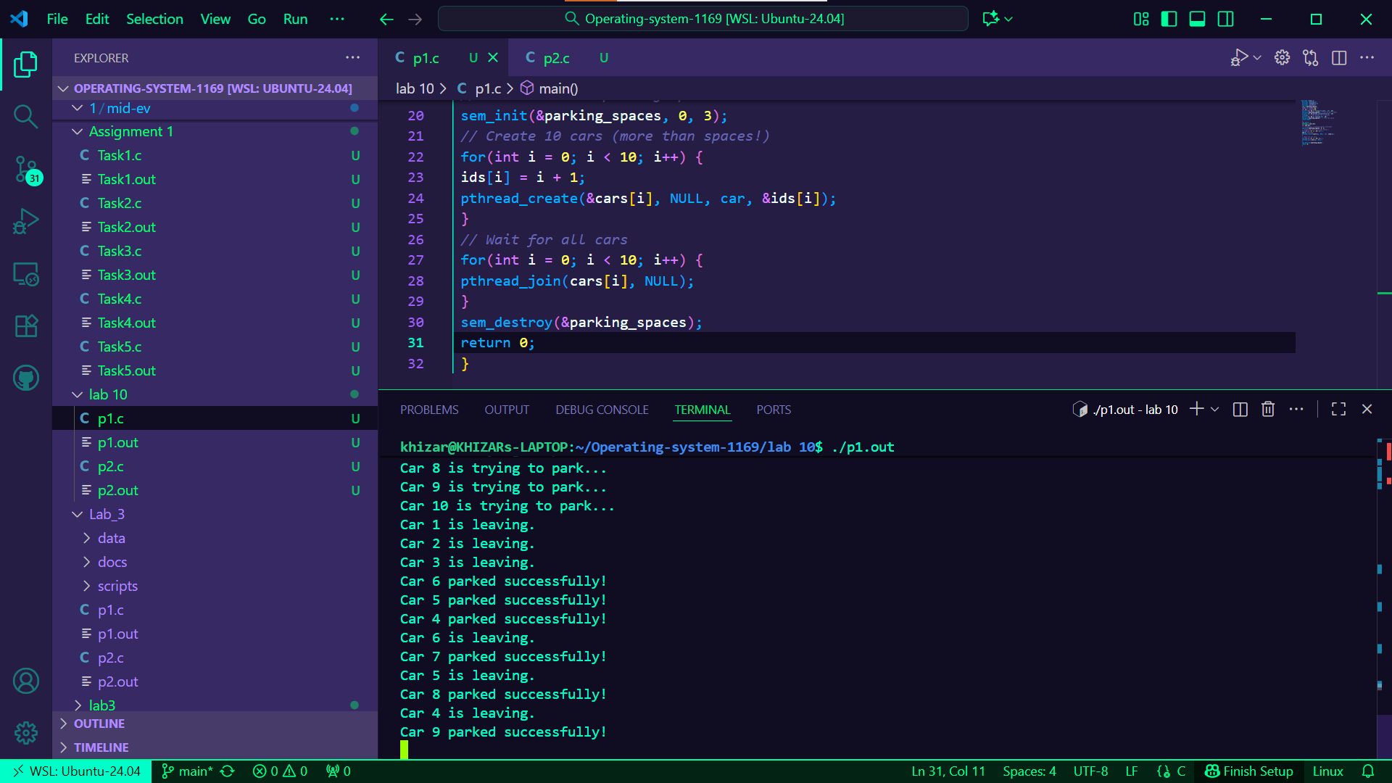
Program 2

Technical Description:
In this program we are making producer and consumer using threads. We have a buffer of size 5 which is shared by all the threads. Two producer threads will create items and two consumer threads will take items out. To stop the threads from interupting each other we use semaphor and mutex.
The empty semafore tells how many empty places are left in buffer and full tells how many items are already in buffer. Producer first waits for empty slot, then lock the mutex and put item in buffer. After that it unlocks and increse the full semafor.
Consumer do the opposite. It waits on full semafore and then lock mutex and take item from buffer. Then it post the empty semafore and sleep.
The values of items are made by id * 100 + i so every producer makes 3 different items. We also use circular buffer so the index go back to 0 after reaching the end.
At the end main function waits for all threads to finish and then destroy the semafors and mutex. This program basicly show how producer consumer problem work using threads.
